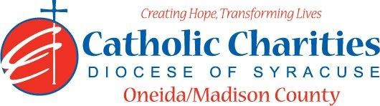

DEPARTMENT: Residential Services Date: February 2024
JOB TITLE: RN Nurse – Part Time Band: 5
STATUS: Non-Exempt

- QUALIFICATIONS

- Education/Qualifications/Requirements
- Current and valid RN license
- Completed or eligible to take OASAS oversight of Patient Self Administration of Medication Part I and Part II.
- A minimum of 1 year experience working with the mental health and or substance use disorder population.

- Experience
- Experience in program and staff planning and development.
- Demonstrated ability to supervise and train others.

- SKILLS
- Demonstrates ability to establish and maintain a professional manner, relationships with clientele and personnel within and outside the Agency, and to work closely with direct care staff.
- Ability to communicate orally and in written form in an organized and concise manner.
- New York State Driver’s License to be used commensurate with program needs.
- Must demonstrate those general skills and personality traits deemed necessary to successfully meet the demands of the position.

- RESPONSIBLE TO

- Assistant Program Officer

- Major Functions/Essential Responsibilities
- Training of staff for the administration of medication and oversight in OMH/OASAS programs.
- Provide educational counseling to residents on prevention and treatment of transmissible infecting HIV, viral hepatitis, TB.
- Reviewing of all medical records.
- Correspond with medical providers as needed.
- Participate in treatment planning.
- Participate in Agency incident review committee.
- Provide staff training annually on transmissible infections, such as TB, HIV, hepatitis, and infection control procedures.
- Education provided medications for addiction treatment.
- OASAS – Act as Health Coordinator to ensure provision of education for risk reduction, counseling, and referral services to all residents re: HIV, TB, Viral hepatitis sexually transmitted infections and other transmissible infections.
- Adhere to mandatory reporting requirements and HIPPA laws.
- Ensure compliance with all pertinent government and agency regulations and operating standards.
- Establish a work environment that creates positive communication between supervisors and employees and assimilates new employees to the Agency’s culture and mission.

- Catholic Charities Agency and Community
- Attending all internal staff meetings and program related meetings, as necessary.
- Participate in in-service training sessions, workshops, conferences and/or continuing education programs within Catholic Charites or the larger community, as necessary.
- Participate in other duties, programs and activities within the Department as directed.

