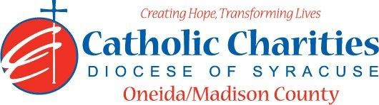
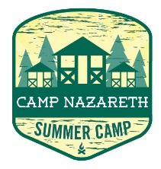
Department: Camp Nazareth
Job Title: Kitchen Assistant
Date: 02/24
Reports to: Food Service Director
Qualifications:
Education/Experience
- Must be at least 16 years of age with previous kitchen experience preferred.
- Ability to be time and schedule oriented.
- Ability to work well with others in a team setting.
- Ability to always act as a positive role model.
- Ability to always maintain professional boundaries with campers and staff.
- Employment is contingent upon approval from Oneida County Health Department. This includes clearance from the NYS Sex Offender Registry and any other regulatory governmental requirements.
Major Function:
Administrative
- Assist in carrying out all kitchen activities.
- Assists in all meal preparation for breakfast, lunch, afternoon snack and dinner. Includes: Menu preparation
- Assisting in maintaining sanitary kitchen and dining hall including garbage disposal, sanitizing all kitchen equipment, operation of dish washer after meals, sweep and mop kitchen and dining hall after evening meal.
- Assist in preparing special event food, as requested by Camp director.
- Assist in programing when not involved in kitchen duty.
- Inform Food Service Director of any situations jeopardizing the health/safety of staff/campers.
- Uphold Camp Nazareth’s philosophy and always abide by proper policy and procedures.

Catholic Charities Agency and Community
- Attending all internal staff meetings and program related meetings, as necessary.
- Participate in in-service training sessions, workshops, conferences and/or continuing education programs within Catholic Charites or the larger community, as necessary.
- Participate in other duties, programs and activities within the Department as directed.

