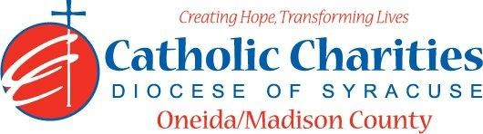
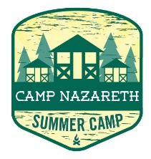
Department: Camp Nazareth
Job Title: Camp Maintenance Assistant
Date: 02/24
Reports to: Camp Director
Qualifications:
Education/Experience
- Must be at least 16 years of age with previous experience in housekeeping and grounds maintenance preferred.
- Ability to accept janitorial duties.
- Ability to be time and schedule oriented.
- Ability to work well with others in a team setting.
- Ability to always act as a positive role model.
- Ability to always maintain professional boundaries with campers and staff.
- Employment is contingent upon approval from Oneida County Health Department. This includes clearance from the NYS Sex Offender Registry and any other regulatory governmental requirements.
Major Function:
Administrative
- Responsible for helping maintain the grounds and buildings at Camp Nazareth during summer camp.
- Assist in cleaning and preparation of all buildings and facilities at Camp Nazareth to prepare camp for opening for rentals and children’s camp to meet Health Department regulations.
- Various Cleaning duties, i.e. clean bathrooms, toilets, sweep, mop, empty garbage and breakdown recyclables.
- Restock paper products and soap in common buildings.
- Collect and dispose of garbage and recyclables around sites and in buildings before meals and throughout the day.
- Assist Maintenance/Groundskeeper with camp wide work projects and maintenance jobs (regular repairs and construction) as assigned.
- Perform all other related duties as assigned by the Maintenance/Groundskeeper or Camp Director.
- Participate fully as part of the overall staff team by working cooperatively with all other staff.
- Work to maintain the overall safety, cleanliness, and hygiene of the camp to ensure the well-being of campers and staff.
- Inform Program Manager of Youth Services of any situations jeopardizing the health/safety of staff/campers.
- Uphold Camp Nazareth’s philosophy and always abide by proper policy and procedures.
- If needed clean up camp emergencies and follow Universal Precautions for Safety.
Catholic Charities Agency and Community
- Attending all internal staff meetings and program related meetings, as necessary.
- Participate in in-service training sessions, workshops, conferences and/or continuing education programs within Catholic Charites or the larger community, as necessary.
- Participate in other duties, programs and activities within the Department as directed.

