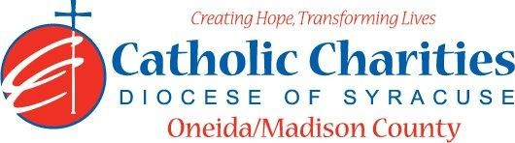
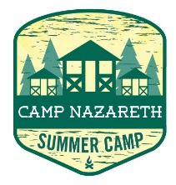
Department: Camp Nazareth
Job Title: Assistant Cook
Date: 02/24
Reports to: Food Service Director
Qualifications:
Education/Experience
- Must be at least 18 years of age with food preparation experience and staff supervision.
- Knowledge of and experience in food service: inventory, food preparation, family style serving, buffet serving, cleaning, and institutional kitchen equipment.
- Ability to work within a budget and purchase supplies effectively.
- Experience in supervising effectively.
- ServSafe certification preferred.
- Ability to stand, sit, or walk for an extended period. Reach overhead and below the knees, including bending, twisting, pulling, and stooping. Move, lift, carry, push, pull, and place objects weighing fewer than or equal to 25 pounds without assistance.
- Ability to work well with others in a team setting.
- Ability to always act as a positive role model.
- Ability to always maintain professional boundaries with campers and staff.
- Employment is contingent upon approval from Oneida County Health Department. This includes clearance from the NYS Sex Offender Registry and any other regulatory governmental requirements.
Major Function:
Administrative
- Direct all kitchen activities.
- Assists in all meal preparation for breakfast, lunch, afternoon snack and dinner. Includes: menu preparation, ensure safe and efficient preparation and serving of camp meals, and assisting in maintaining food/milk inventory
- Assist with carrying out food allergy process and ensure all dietary requirements are met for campers and staff.
- Assisting in maintaining sanitary kitchen and dining hall including maintain and check food preparation equipment for cleanliness and safety, sanitizing all kitchen equipment/Maintaining garbage disposal, maintain refrigeration at proper temperature, participation in completion of sweeping and mopping of kitchen and dining hall after evening meal or at any times which it warrants completion.
- Prepare special event food, as requested by the Camp director.
- Assist Assistant Camp Director weekly Camp Canteen food and drink products.
- Inform Food Service Director of any situations jeopardizing the health/safety of staff/campers.
- Uphold Camp Nazareth’s philosophy and always abide by proper policy and procedures.
Catholic Charities Agency and Community
- Attending all internal staff meetings and program related meetings, as necessary.
- Participate in in-service training sessions, workshops, conferences and/or continuing education programs within Catholic Charites or the larger community, as necessary.
- Participate in other duties, programs and activities within the Department as directed.

