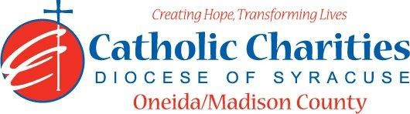
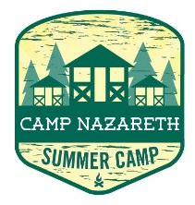
Department: Camp Nazareth
Job Title: Camp Aquatics Director
Date: 02/24
Reports to: Camp Director
Qualifications:
Education/Experience
- Must be at least 21 years of age with 2 years of college and have a minimum of
One season of previous experience as a Camp Aquatics Director at a New York State Children’s Camp
OR
Two seasons of previous experience consisting cumulatively of at least 12 weeks as a children’s camp lifeguard at a swimming pool or bathing beach which had more than one lifeguard supervising at a time.
OR
At least 18 weeks of previous experience as a lifeguard at a swimming pool or bathing beach which had more than one lifeguard supervising it at a time.
- Current Lifeguard Supervision Certificate
- Current Water Safety Instructor Certification matching NYS requirements for Level II beach or be willing to obtain necessary certification prior to camp.
- Current CPR (within 1 year) and First Aid Certification (within 3 years)
- Experience in residential or day camp environments preferred.
- Ability to work well with others in a team setting.
- Ability to always act as a positive role model.
- Ability to always maintain professional boundaries with campers and staff.
- Employment is contingent upon approval from Oneida County Health Department. This includes clearance from the NYS Sex Offender Registry and any other regulatory governmental requirements.
Major Function:
Administrative
- Direct all waterfront activities including a strict water safety program.
- Ensure maximum safety of all staff and campers when at waterfront (boating or swimming)
- Develop and implement Red Cross swimming program.
- Supervise waterfront and boat staff.
- Evaluate all staff and campers upon arrival and place in appropriate swim categories.
- Maintain detailed waterfront log for Oneida County Health Department
- Annually review and document review of Camp Nazareth’s Safety Plan for swimming.
- Maintain beachfront first aid kit in waterfront supply room.
- Inventory and maintain waterfront safety equipment, canoes/rowboats, and paddles.
- Maintain beach.
- Implement lost camper water search and direct lifeguard staff.
- Direct camper “buddy system”
- Inform Director of any situations jeopardizing the health/safety of staff/campers
- Assist in programming during non-waterfront activities.
- Water testing at beach and for bath and kitchen water systems.
- Responds to waterfront emergencies.
- Serve as Lifeguard as needed.
- Uphold Camp Nazareth’s philosophy and always enforce proper policy and procedures
Supervisory
- Supervise waterfront and boat staff.
Catholic Charities Agency and Community
- Attending all internal staff meetings and program related meetings, as necessary.
- Participate in in-service training sessions, workshops, conferences and/or continuing education programs within Catholic Charites or the larger community, as necessary.
- Participate in other duties, programs and activities within the Department as directed.

