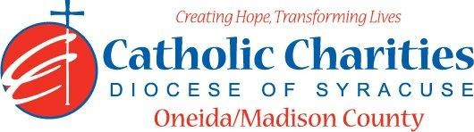

DEPARTMENT: Accounting DATE: 03/24
JOB TITLE: Accounting/Payroll Clerk BAND: 3
STATUS: Non-Exempt

QUALIFICATIONS
Education/Experience
- Associate’s degree in accounting or business-related field with 2 – 3 years of accounting experience
OR
- A High School Diploma with 5 – 7 years of experience in accounting

Skills
- Demonstrated ability to work with different disciplines on administrative and direct service levels.
- Ability to be creative in problem solving techniques, organize time, prioritize tasks, and work assignments, as necessary.
- Valid New York State Driver’s license with less than 4 points.
- Effective oral and written skills
- Ability to work independently and as a part of a team
- Basic Microsoft Excel skills
- Basic math skills
- Detail oriented
- Problem solving skills
- Ability to maintain confidentiality of sensitive information

RESPONSIBLE TO

- Controller

MAJOR FUNCTIONS
Administrative
- Required to follow all Agency policies and procedures, using the Policy and Procedures manual as a reference.
- Required to understand and abide by those laws, regulations, policies, and procedures applicable to the program/service you are providing.
- Required to report any known or suspected violations of laws, regulations, policies, and procedures related to programs/services of the agency.
- Prepare and submit bi-weekly payroll data to payroll service within prescribed periods.
- Maintaining payroll information by collecting, calculating, and entering data.
- Updating payroll records by entering any changes to employee information or benefits such as job title changes, exemptions, and saving deductions.
- Preparing reports that include summaries of earnings, tax deductions, leave, compassionate leave and non-taxable wages.
- Resolve payroll discrepancies and answer employee payroll questions.
- Maintain all payroll operations according to company policies and procedures.
- Assist in processing and issuing W-2 forms to employees.
- Bank reconciliations of operating and other accounts.
- Daily receipt of funds, electronically and in person.
- Prepare bank deposits.
- Data entry of budget and other functions.
- Receive and distribute Finance Department USP Mail.
- Cross train and provide back-up to other positions in the department.
- Update and maintain client balances.

Catholic Charities Agency and Community Related
- Attending all internal staff meetings and program related meetings, as necessary.
- Participate in in-service training sessions, workshops, conferences and/or continuing education programs within Catholic Charites or the larger community, as necessary.
- Participate in other duties, programs and activities within the Department as directed.

