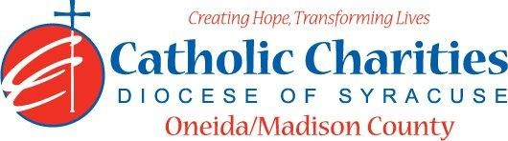
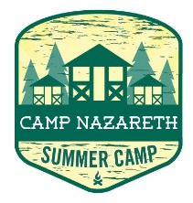
Department: Camp Nazareth
Job Title: Lead Counselor
Date: 02/24
Reports to: Assistant Camp Director
Qualifications:
Education/Experience
- Must be at least 18 years of age with previous experience in camping and supervision of children.
- Experience and training in special activity areas, such as archery, arts and crafts, sports and/or character education.
- Ability to work well with others in a team setting.
- Ability to always act as a positive role model.
- Ability to always maintain professional boundaries with campers and staff.
- Employment is contingent upon approval from Oneida County Health Department. This includes clearance from the NYS Sex Offender Registry and any other regulatory governmental requirements.
Major Function:
Administrative
- Responsible for immediate supervision of campers, provide leadership and guidance to all Counselors and CIT.
- Ensure maximum safety for all campers.
- Interpret camp safety and health regulations for campers.
- Supervise cabin/bunker behavior and housekeeping.
- Coordinate and lead cabin/bunker activities.
- Act as host/hostess in dining hall.
- Maintain daily logbook.
- Lead special activity groups.
- Escort campers to and from all daily activities.
- Provide supervision during daily programs.
- Assist in activity planning and lead activities.
- Assist on Sunday registration.
- Complete cabin/bunker clean-up and preparation for Sunday arrivals before departure on Friday evenings.
- Inform Assistant Camp Director/Health Director of any situations jeopardizing the health/safety of staff/campers.
- Uphold Camp Nazareth’s philosophy and always abide by proper policy and procedures.
- Provide oversight for allergy maintenance of assigned campers with support of Health Director.
Supervisory
- Provide supervision and leadership for Counselors, Campers and CIT to carry out a safe camp experience.
- Ensure that Counselors, Campers and CIT are participating in daily activities.
Client/Program Related
- Design and develop ongoing summer camp programs at camp.
- Oversee and actively participate in the registration drop off and pick up process.
- Develop camp maintenance priority list and refer to Agency Administration.
- Assist in all other assigned areas.
Catholic Charities Agency and Community
- Attending all internal staff meetings and program related meetings, as necessary.
- Participate in in-service training sessions, workshops, conferences and/or continuing education programs within Catholic Charites or the larger community, as necessary.
- Participate in other duties, programs and activities within the Department as directed.

