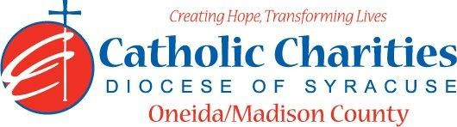
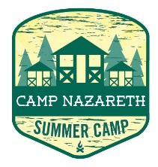
Department: Camp Nazareth
Job Title: Counselor In Training- CIT (volunteer)
Date: 02/24
Reports to: Lead Counselor
Qualifications:
Education/Experience
- Must be 16 or 17 years of age and have two years of camper experience.
- Are patient, friendly, cooperative, outgoing, and approachable.
- Ability to always act as a positive role model with maturity, responsibility, and leadership skills.
- Ability and desire to work with children.
- Easily takes direction from Camp Staff.
- Have reliable transportation to and from Camp Nazareth weekly.
- Can commit to at least TWO weeks- One week of training and at least one week of residential camping. A FOUR-week commitment is preferred.
- Employment is contingent upon approval from Oneida County Health Department. This includes clearance from the NYS Sex Offender Registry and any other regulatory governmental requirements.
Major Function:
Administrative
- Assist Camp Staff with leadership and guidance of campers in daily living skills with special attention to: Personal Hygiene and Safety, Camper Participation in camp activities, Camper personal growth, self-confidence, and independence through group living, activity planning.
- Actively participates in camp activities including games, sing along, campfires, etc.
- Serves as a role model and example to campers in personal language, appearance, manners, and health habits.
- Assists camp staff in daily activities as directed by the Lead Counselors
- Never is left alone with campers.
- Must always remain with Camp Staff under their supervision.
- Must submit all camper required documents to include Physical, Camper Code of Conduct, and Registration form.
- Maintain appropriate boundaries with Campers.
- Uphold Camp Nazareth’s philosophy and always abide by proper policy and procedures.
Catholic Charities Agency and Community
- Attending all internal staff meetings and program related meetings, as necessary.
- Particpate in in-service training sessions, workshops, conferences and/or continuing education programs within Catholic Charities or the larger community, as necessary.
- Participate in other duties, programs and activities with the Department as directed.

