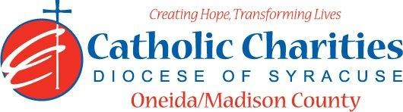
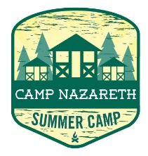
Department: Camp Nazareth
Job Title: Camp Nurse/EMT
Date: 02/24
Reports to: Camp Health Director
Qualifications:
Education/Experience
- Must be a NYS licensed physician, nurse practitioner, physician assistant or registered nurse, licensed practical nurse, or emergency medical technician.
- Current Certificate in an acceptable first aid training program (within 3 years) or be willing to take accepted training.
- Current Certificate in an acceptable (www.health.ny.gov)cardiopulmonary resuscitation (CPR) training program (within 1 year) or be willing to take accepted training.
- Ability to work well with others in a team setting.
- Ability to always act as a positive role model.
- Ability to always maintain professional boundaries with campers and staff.
- Employment is contingent upon approval from Oneida County Health Department. This includes clearance from the NYS Sex Offender Registry and any other regulatory governmental requirements.
Major Function:
Administrative
- Assist with overall camp health program, insures health and safety of all campers and staff.
- Assists with maintaining the infirmary in pleasant sanitary condition and keep all medical supplies in locked cabinet.
- If Qualified to do so, dispense medication to campers and staff.
- Review medical information of all campers prior to arrival for completion.
- Review staff medical records for accuracy.
- Maintain accurate camper/staff medical records in file arranged alphabetically with campers arranged by week.
- Maintain accident report forms and daily log.
- Assist with reporting to Oneida County Health Department and Program Manager within 24 hours of camper’ staff requiring hospital services, artificial resuscitation or CPR, illness due to food or water contamination, allegation of child abuse.
- Assist with morning inspection.
- Assists and completes initial health screenings for all campers.
- Inform Director of any situations jeopardizing the health/safety of staff/campers.
- If needed, you will need to be able to get to all parts of camp to assess a medical emergency. For example, hiking or canoeing.
- Uphold Camp Nazareth’s philosophy and always abide by proper policy and procedures.
Catholic Charities Agency and Community
- Attending all internal staff meetings and program related meetings, as necessary.
- Participate in in-service training sessions, workshops, conferences and/or continuing education programs within Catholic Charites or the larger community, as necessary.
- Participate in other duties, programs and activities within the Department as directed.

