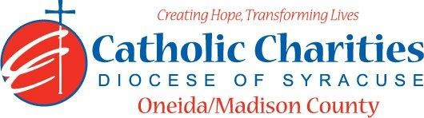
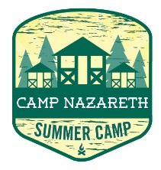
Department: Camp Nazareth
Job Title: Lifeguard
Date: 02/24
Reports to: Camp Aquatics Director
Qualifications:
Education/Experience
- Must be at least 17 years of age with previous lifeguarding experience preferred. 18 years of age for rentals.
- Current Lifeguard Supervision Certificate
- Current Water Safety Instructor Certification matching NYS requirements for Level II beach or obtain necessary certification before camp.
- Current CPR (within 1 year) and First Aid Certification (within 3 years)
- Experience in residential or day camp environments preferred.
- Ability to work well with others in a team setting.
- Ability to always act as a positive role model.
- Ability to always maintain professional boundaries with campers and staff.
- Employment is contingent upon approval from Oneida County Health Department. This includes clearance from the NYS Sex Offender Registry and any other regulatory governmental requirements.
Major Function:
Administrative
- To protect the life and well-being of all campers and staff on the waterfront.
- Provide maximum safety for all campers/staff while on the waterfront.
- Maintaining waterfront coverage at all open beach times
- Complete tasks assigned by Waterfront Aquatics Director
- Assist in programming during non-waterfront activities.
- Inform Camp Aquatics Director of any situations jeopardizing the health/safety of staff/campers.
- Respond to waterfront emergencies.
- Complete water testing as required for beach, bath and/or kitchen water systems.
- Uphold Camp Nazareth’s philosophy and always abide by proper policy and procedures.
Catholic Charities Agency and Community
- Attending all internal staff meetings and program related meetings, as necessary.
- Participate in in-service training sessions, workshops, conferences and/or continuing education programs within Catholic Charites or the larger community, as necessary.
- Participate in other duties, programs and activities within the Department as directed.

