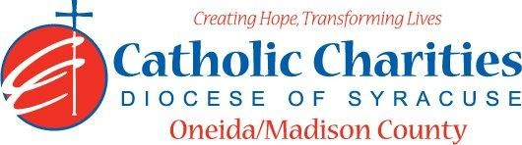
Department: Camp Nazareth
Job Title: Counselor
Date: 02/24
Reports to: Assistant Camp Director
Qualifications:
Education/Experience
- Must be at least 18 years of age with previous experience in camping and supervision of children. (20% of staff can be 17 years of age)
- Experience and training in special activity areas, such as archery, arts and crafts, sports and/or character education.
- Ability to work well with others in a team setting.
- Ability to always act as a positive role model.
- Ability to always maintain professional boundaries with campers and staff.
- Employment is contingent upon approval from Oneida County Health Department. This includes clearance from the NYS Sex Offender Registry and any other regulatory governmental requirements.
Major Function:
Administrative
- Responsible for immediate supervision of campers, provide leadership and guidance to all campers.
- Ensure maximum safety for all campers.
- Interpret camp safety and health regulations for campers.
- Supervise cabin/bunker behavior and housekeeping.
- Coordinate and lead cabin/bunker activities.
- Act as host/hostess in dining hall.
- Maintain daily logbook.
- Lead special activity groups.
- Escort campers to and from all daily activities.
- Provide supervision during daily programs.
- Assist Lead Counselor in activity planning and lead activities.
- Assist on Sunday registration.
- Complete cabin/bunker clean-up and preparation for Sunday arrivals before departure on Friday evenings.
- Inform Assistant Camp Director of any situations jeopardizing the health/safety of staff/campers.
- Inform Lead Counselor of any situations jeopardizing the health/safety of campers/staff.
- Uphold Camp Nazareth’s philosophy and always abide by proper policy and procedures.

Catholic Charities Agency and Community
- Attending all internal staff meetings and program related meetings, as necessary.
- Participate in in-service training sessions, workshops, conferences and/or continuing education programs within Catholic Charites or the larger community, as necessary.
- Participate in other duties, programs and activities within the Department as directed.

